Project Design Phase Solution Architecture

Date | 15 February 2026
Team ID | LTVIP2026TMIDS78241
Project Name | LearnHub: Your Center for Skill Enhancement
Maximum Marks | 4 Marks

Solution Architecture:
Solution architecture is a complex process – with many sub-processes – that bridges the gap between business problems and technology solutions. Its goals are to:

- Find the best tech solution to solve existing business problems.
- Describe the structure, characteristics, behavior, and other aspects of the software to project stakeholders.
- Define features, development phases, and solution requirements.
- Provide specifications according to which the solution is defined, managed, and delivered.

LearnHub – Solution Architecture Diagram:
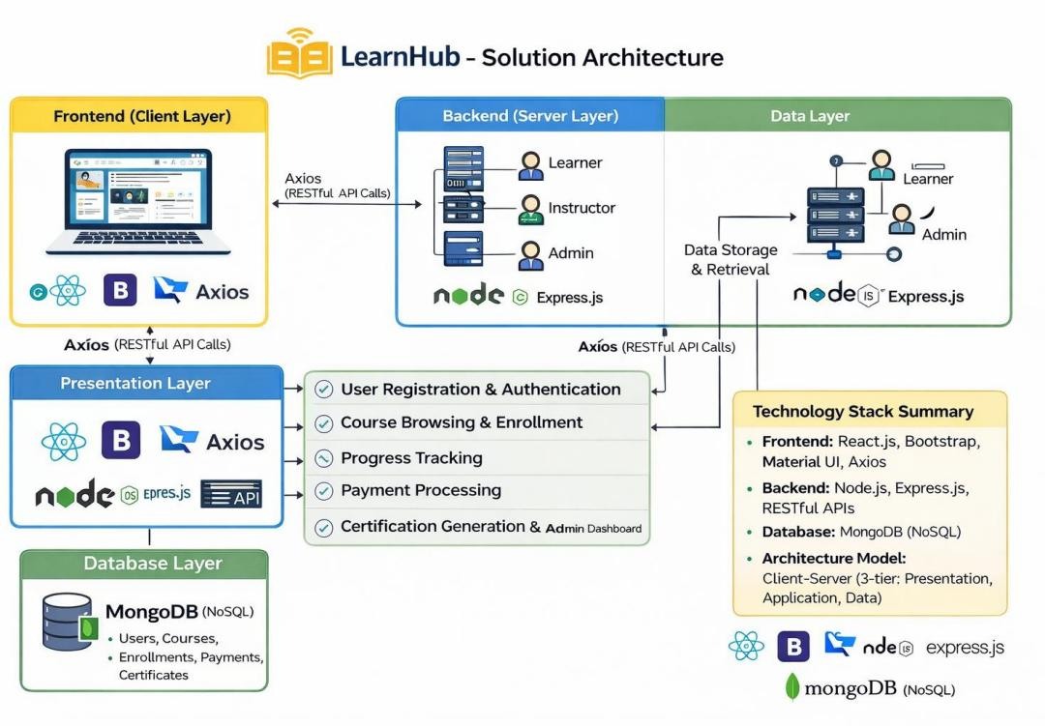

Figure 1: LearnHub Client-Server (MERN Stack) Architecture – Frontend (React.js) communicates with Backend (Express.js/Node.js) via RESTful APIs, with MongoDB as the data store

LearnHub – Solution Architecture:
Overview:
LearnHub follows a Client-Server (MERN stack) architecture. The frontend (client) communicates with the backend (server) via RESTful APIs using the Axios library. The platform is designed for scalability, real-time responsiveness, and cross-device accessibility.

Architecture Layers:
- Frontend (Client Layer): Built with React.js, styled using Bootstrap and Material UI. Handles all user interactions — browsing courses, enrollment, video playback, and certification display. Axios is used for API communication
with the backend.
- Backend (Server Layer): Powered by Node.js and Express.js. Manages RESTful API endpoints for authentication, course management, enrollment, payment processing, and user progress tracking. Handles business logic for
all three user roles: Learner, Instructor, and Admin.
- Database Layer: MongoDB (NoSQL) is used for scalable and flexible data storage. Collections include Users, Courses, Enrollments, Payments, and Certificates.

Key Components and Data Flow:
- User Registration & Authentication: Users register/login via a React form. Credentials are sent via Axios POST to the Express.js API, which validates and stores user data in MongoDB.
- Course Browsing & Enrollment: Learners browse courses fetched via GET API from MongoDB. On enrollment, a POST request creates an enrollment record linking the user and course.
- Progress Tracking: The backend persists progress data in MongoDB. On each session, the frontend fetches the learner’s last position and resumes accordingly.
- Payment Gateway: Paid course purchases are handled via a secure payment API route. Payment status is stored in MongoDB and access is granted upon successful transaction.
- Certification: On course completion, the backend generates a digital certificate record and returns it to the frontend for download.
- Admin Dashboard: Admins interact with a dedicated panel to monitor enrollments, manage course listings, and oversee platform activity via protected API routes.

Technology Stack Summary:

- Frontend: React.js, Bootstrap, Material UI, Axios
- Backend: Node.js, Express.js, RESTful APIs
- Database: MongoDB (NoSQL)
- Architecture Model: Client-Server (3-tier: Presentation, Application, Data)

Reference: https://github.com/NCHAKRADHAR-SINGH1/learnhub-project

